Scenario: Pizza Delivery Order System
You are building a simple C program for a pizza shop to take orders and calculate the total cost.
Question 1:
Ask the user to choose a pizza size: 1. Small, 2. Medium, 3. Large. Print the chosen size. If they choose wrong, print "Invalid size."

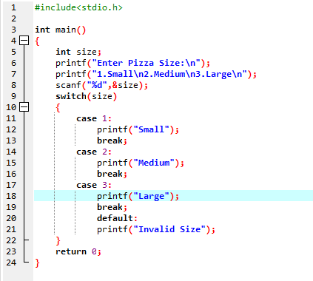
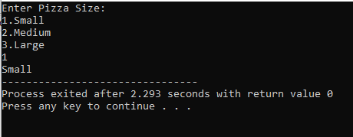
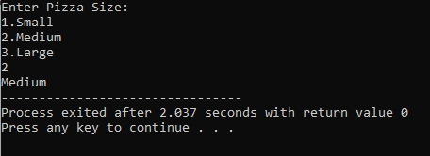
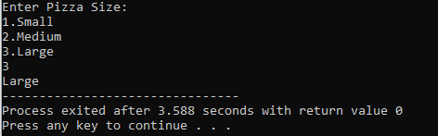
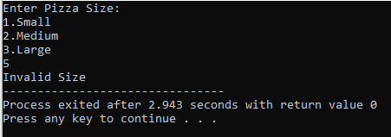

Question 2:
A small pizza costs $8. Ask how many pizzas they want. If they want more than one, print "Check our multi-pizza deals." Otherwise, print "Your total is $8."

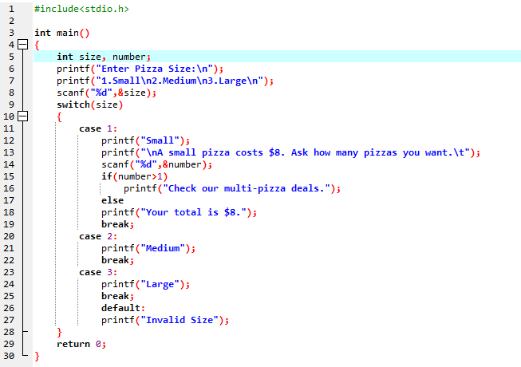

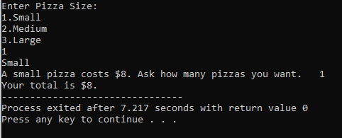
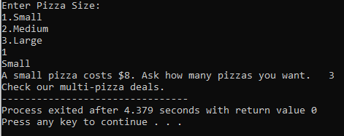
Question 3:
Ask how many pizzas they want (1, 2, or 3). 1 pizza costs $8, 2 pizzas cost $15, and 3 pizzas cost $21. Calculate and print the total cost with number of pizza.

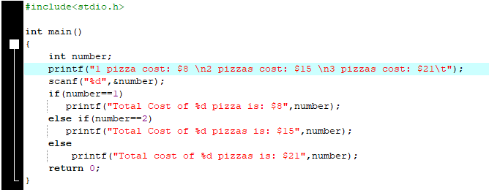

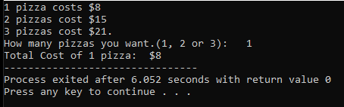
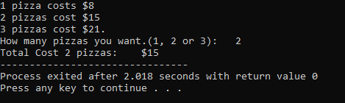
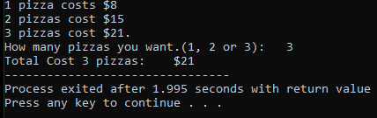
Question 4:
Ask for crust type and add the cost to the total. Print the new total Cost.
- Regular crust: $0
- Thin crust: $1
- Stuffed crust: $2

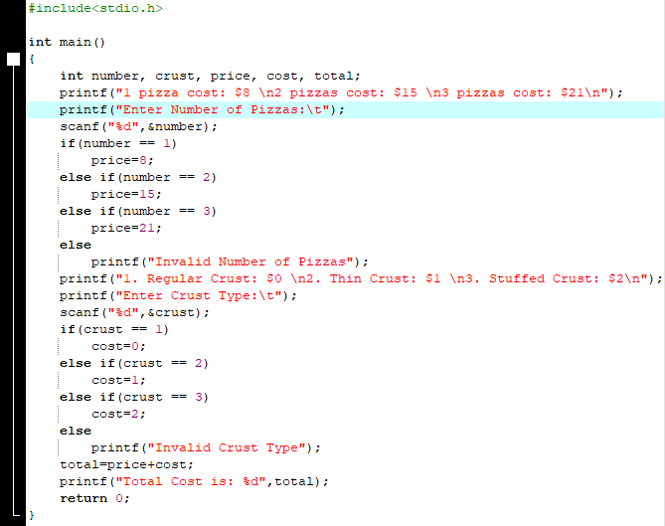
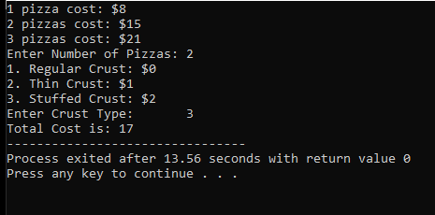

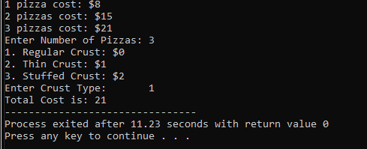

Question 5:
Ask if they want extra cheese (Y/N). If yes, add $1.50 to the total.
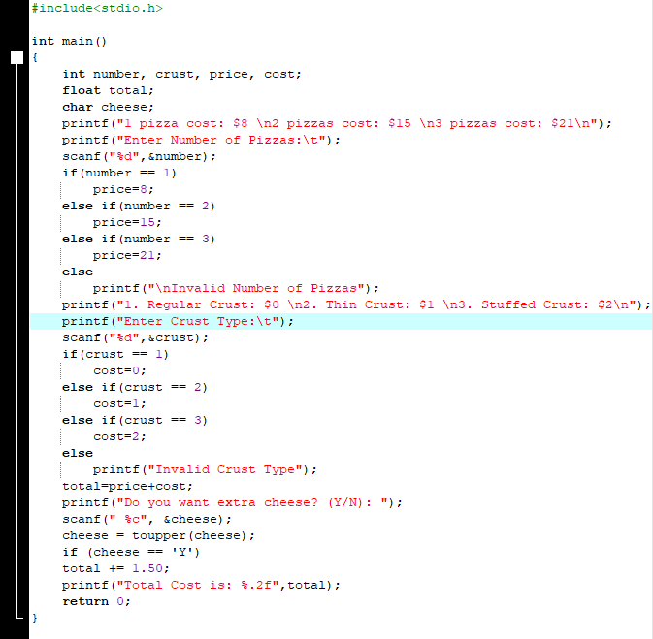

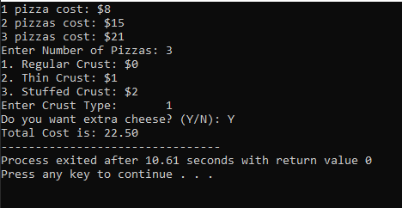
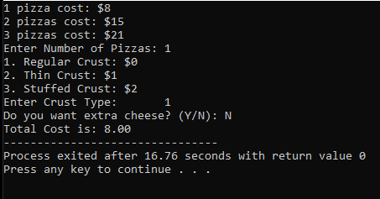
Question 6:
Between 11 AM and 2 PM, there's a 10% discount. Ask for the current time (0-23). If the time is between 11 and 14, apply the discount. Print the discounted total.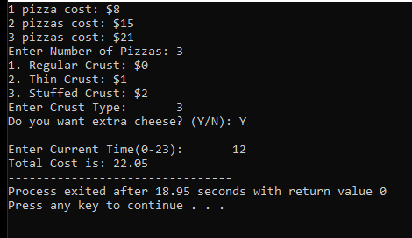

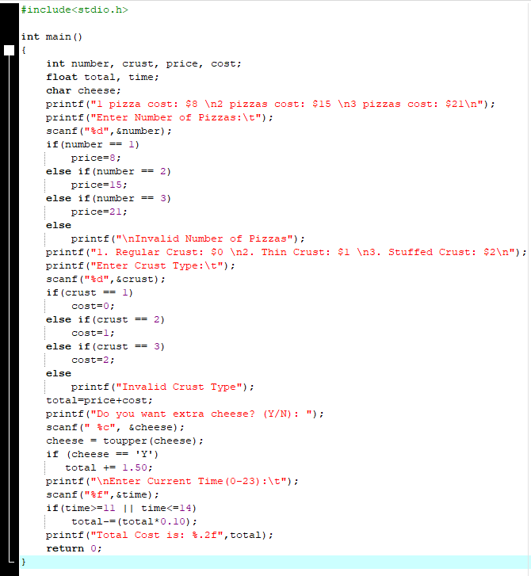

Question 7:
Students get $2 off. Ask if they have a student ID (Y/N). If yes, subtract $2 from the total. Print the final cost.

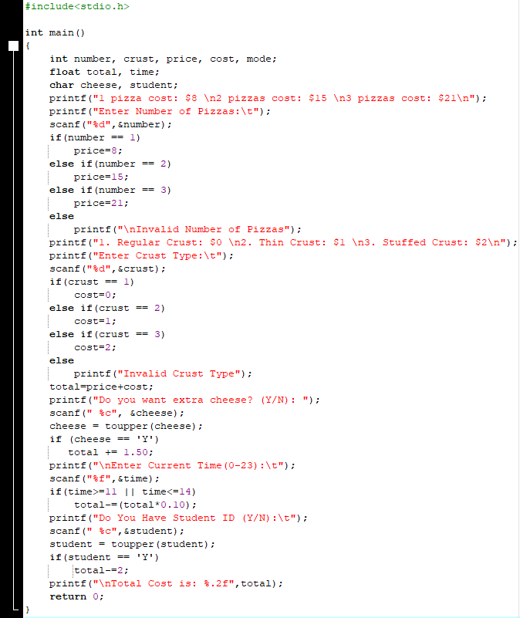

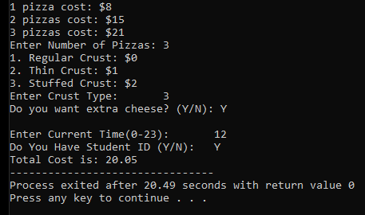
Question 8:
If they order 3 pizzas with stuffed crust, print "You get free garlic bread!"

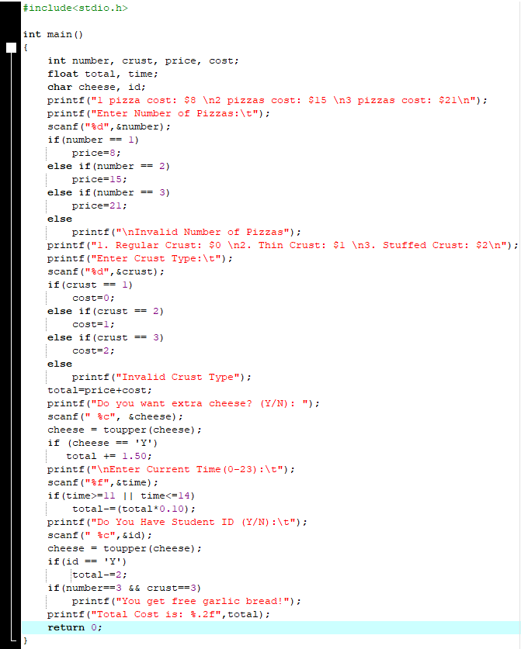
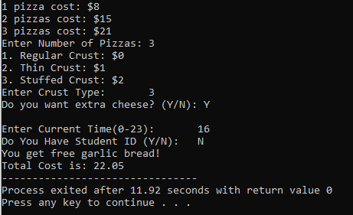
Question 9:
If they want delivery, add $3. Ask if it's delivery or pickup (1. Pickup, 2. Delivery). Calculate the final cost.

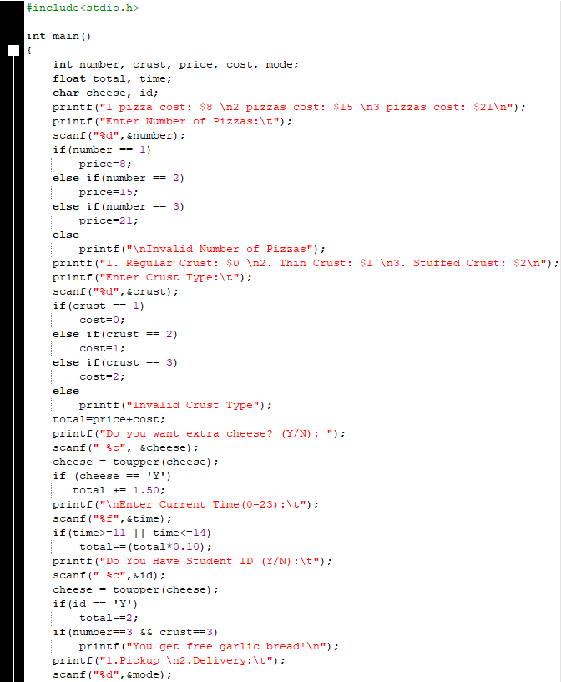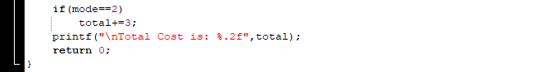

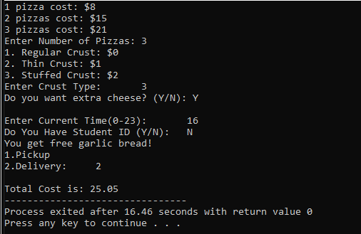
Question 10:
Combine all into one program:
- Ask for size, number of pizzas, crust type, extra cheese, time, student status, and delivery option.
- Calculate the total cost step by step.
- Print a receipt with the final amount and any free items.

